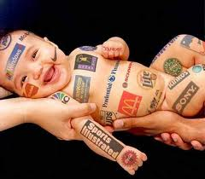
What’s Your Brand?
If you could create a brand for yourself what would it look like? How would others perceive it? Would you be marketable?

Do the following tasks to complete this activity:
Draw your initials, including your middle initial (mine would be TNH) in fat, balloon type letters. You will be filling the inside of each letter with pictures, colors, words, and symbols etc. that describe your brand.

Fill your initials with the following:

First letter should include illustrations about how you view yourself. What are your values, attitudes, beliefs, hobbies etc.? What “level of quality” are you?

Second letter should include illustrations of how you want your peers to view you. Why would someone want to spend time with you? What qualities do you possess? How are you going to position yourself in the minds of your peers?

Third letter should include illustrations representing how you would like a future employer to perceive you. What makes you better than your competition (others applying for the same job)? What skills do you possess? What are you good at doing?

Note: Fill your letters completely, like a collage. Leave no “white” space in your letters. When you are finished, cut the letters out so that all three letters are one piece.

