February 15, 2013

Dear Sir or Madam,

Rock Revolution is a brand new hip hop dance club at Round Rock High School whose aim is to change the face of Hip Hop dance in the Round Rock community. Rock Revolution is comprised of both males and females in grades 9-12. The club prides itself in being inclusive while valuing the uniqueness of each member of the club. Club members come from various dance backgrounds but have a love for hip hop and for creativity in common.

As a new club on the Round Rock High School campus we are responsible for generating funds that contribute to the growth and success of our club. We started with no funds but this year we have already raised enough money to pay for two professionally choreographed routines which have been performed throughout the community. At this time we are still in need of funds for club t-shirts, competitions and a general operating budget. We would also like to attend hip hop dance workshops that will provide us with the tools to further our knowledge and practice of hip hop dance. We will be holding a community dance clinic in April to raise funds so that the club can continue to have the choreography, and costuming necessary to be successful.

We are currently raising funds to support Rock Revolution for the remainder of the 2012-2013 school year. We are seeking business and individual sponsors to help enable us to purchase costumes, supplies, hire choreographers, and fund our team-building events. All proceeds from these sponsorships will go directly to support the Rock Revolution.

All sponsors will be recognized throughout the year at our various events. We will also strongly encourage our Rock Revolution families to in turn support our Sponsors with their business.
All donations are tax-deductible.

Thank you,

Tiffanie Harrison
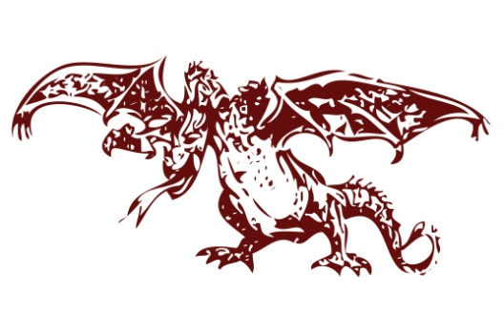
Rock Revolution Faculty Sponsor
tiffanie_harrison@roundrockisd.org
512.464.6254

Round Rock High School
300 N Lake Creek Dr
Round Rock, TX 78681

Our Sponsorship Recognition Program includes the following levels of commitment:

Revolution Sponsor: $300
A Personal Appearance at Your Place of Business of Choice of Community Event
Name and Logo Included on Any Performance Programs in which Rock Revolution Takes Part
Name and Logo Featured Prominently on the Back of Sponsorship T-Shirt
Name, Website Link and Logo Featured on Club Website

Rock Sponsor: $150
Name and Logo Featured Prominently on the Back of Sponsorship T-Shirt
Name and Logo Featured on Club Website

Friends and Family of Rock Revolution: $50
Name Featured Prominently on the Back of Sponsorship T-Shirt
Name Featured on Club Website

Various sponsorship levels allow individuals and companies to support Rock Revolution at the level in which they are comfortable. Your support will allow the club members the opportunity to grow as both a team and an individual. We appreciate any level of support that you can give the members of Rock Revolution.

Please contact Tiffanie Harrison at tiffanie_harrison@roundrockisd.org or 512.464.6254 for additional information or to participate in the program.

Individual or Corporate Sponsorship Level: _____________________________

Company/Sponsor Name: _______________________________________________________________

Address: _____________________________________________________________________________

Phone Number: _______________________________________________________________________

Email & Website URL: ___________________________________________________________________

Rock Revolution Reference: ______________________________________________________________

Please Make Checks Payable to:
Round Rock High School. Please include Rock Revolution in the subject line.
Donations to Round Rock High School Club are tax-deductible. We are a 501C Organization.

Mail forms and donations to:
Rock Revolution Hip Hop Club
c/o Tiffanie Harrison
300 North Lake Creek Dr
Round Rock, TX 78681

