Case Study: Levi’s
Read the Levi’s case study on the Case Study. As you read the article, highlight the important points, and then answer the following questions.

Answer the following questions (in your own words):

- In one paragraph, summarize the marketing plan for Levi’s:

- What was the objective (overall goal) of the facebook plan?

- Describe the target market:
  - Demographics (age, income, etc.)
  - Psychographics (lifestyle)
  - Geographics (physical location)
  - Product Benefits (what do the consumers gain)

- How did the company benefit?

- If you were in charge of running a 2015 campaign, how would you expand on their previous success? (You will present this in the same powerpoint format as before for your final exam)
  - For this last question, you will present a marketing plan that will include the following:
    - Objective – what are the goals of Levi’s 2015 campaign?
    - Target Market
    - Approach – what is your plan to increase exposure to the campaign?
    - Other materials – visual aid, promotional items, contests and prizes, etc.
  - *You will be graded on creativity, originality, and feasibility (is it doable?)

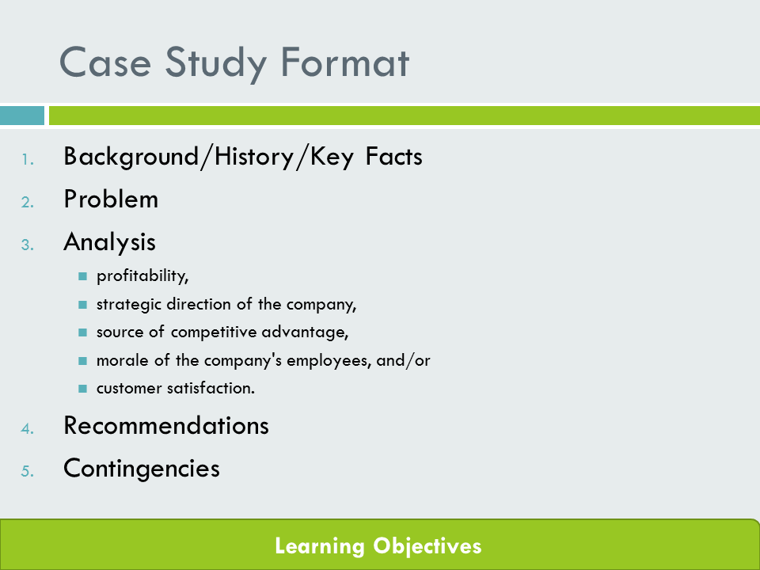
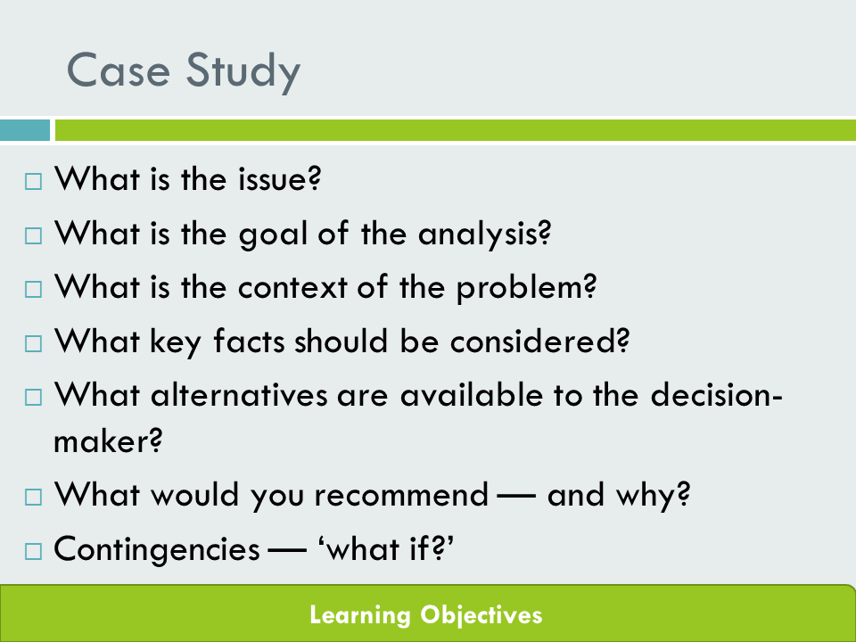
Once your project is complete, attach the highlighted article, and the answers to your questions. These grades will be individual. Your presentation will be a group grade.

