ENTREPRENEUR PERSONALITY ACTIVITY

Complete steps 1-6 on a blank word document and save it to your H: drive. When completed share with me on Google Drive.

Step 1: Go to www.careercruising.com. On the first screen, username: rrhs, password: roundrock.
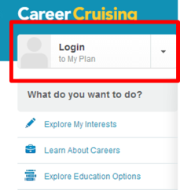
On second screen in top left-hand corner click white ‘Login to My Plan’ button. Your ID is ROCK-XXXXXX" where the Xs are your school ID number. Your individual password is your birthday in the form "MMDDYYYY" unless you’ve changed it. At top of page click Assessments Matchmaker & My Skills Start New Matchmaker.
Complete the career matchmaker on the computer and write down your top 10 career suggestions. Save this to your account.

Step 2: Write a paragraph on why you believe that your job suggestions were right or wrong for you. Elaborate.

Step 3: Write a paragraph on why or why not you believe that you will be a successful entrepreneur. Elaborate. Note: Be honest with your self.

Step 4: Pick 3 famous entrepreneurs who you would want to research. List them and their company. Are they related to any of your career suggestions? Why or why not?

Step 5: Character counts in business. Define intrapersonal and interpersonal and then define each of the following character traits needed in business listed below.

Intrapersonal Character traits for business are:
- Responsibility
- Contemplation
- Initiative
- Perseverance
- Optimism
- Courage

Interpersonal Character traits for business are:
- Respect
- Compassion
- Adaptability
- Honesty
- Trustworthiness
- Loyalty.

Step 6: Answer additional questions on www.careercruising.com to see if your career suggestions changed. Write a paragraph on why you think your suggestions changed and if these are a better fit. Save this again.

Step 7: Share this with me on Google Drive.

