Microsoft Publisher
College Brochure Assignment

Brochure- create a brochure that describes all of the activities for the college of your choice’s welcome week for new students (to orient them to the college 1 week before classes begin).
- 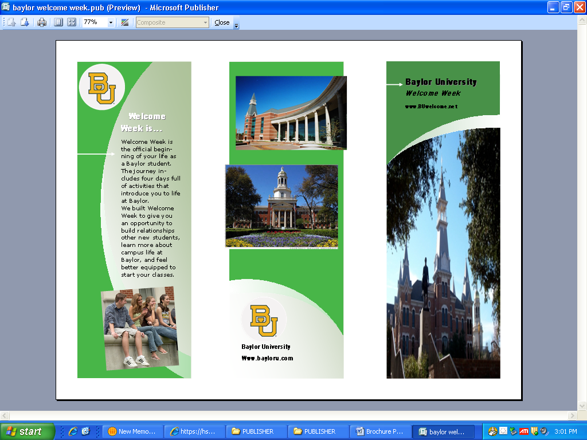Front panel 1
  - College name
  - “Welcome Week” (or whatever you want to call it)
  - Graphic(s)/ illustration(s)
- Front panel 2
  - the dates of welcome week
  - welcome week explanation
  - Graphic(s)/ illustration(s)
- Back panel
  - University logo & Illustration(s)
  - Address
  - website
- Inside panels
  - section for each day of the week (at least 3)
  - activities for that day
BACK PANEL
FRONT PANEL 2
FRONT PANEL 1
  - include illustration(s) for each day
- Print in black and white, fold, and turn in (make sure your NAME is on it!)

*Go to the college website and look for activities associated.

Ideas: Check out Rice “O”Week at http://oweek.rice.edu/

SUNDAY, August 17
Move-In
Lunch with Families
Activities with O-Week Groups
Matriculation
MONDAY, August 18
Master's Presentation: Academics at Rice
Faculty Address
Special Academic Orientations
TUESDAY, August 19
University Presentations
Academic Fair
Rice Night featuring Rice Rally and Rice Carnival
WEDNESDAY, August 20
University Presentations
Academic Advising
Associates' Dinner
THURSDAY, August 21
University Presentations
Academic Advising
Houston Engagement Opportunities
FRIDAY, August 22
Course Registration
Honor Code Exam
Houston Night Out
SATURDAY, August 23
Outreach Day

You might also consider throwing in a campus map!

Remember, you are targeting newbies like yourself into the college campus/life of your choice. Include what you think would be most beneficial (helpful) for you and your peers to really get situated and comfortable with what they are about to embark on.

MAKE IT COOL! Save in your H:Drive ‘Publisher’ folder when finished. If you don’t have one…make one!
