Styles
A style is a format enhancing tool that includes font typefaces, font size, effects (bold, italics, underline, etc.), colors and more. You will notice that on the Home Tab of the Ribbon, that you have several areas that will control the style of your document: Font, Paragraph, and Styles.
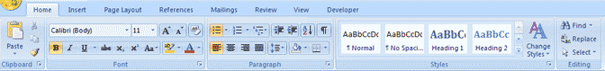
Change Font Typeface and Size
To change the font typeface:
- Click the arrow next to the font name and choose a font.
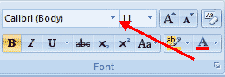
- Remember that you can preview how the new font will look by highlighting the text, and hovering over the new font typeface.
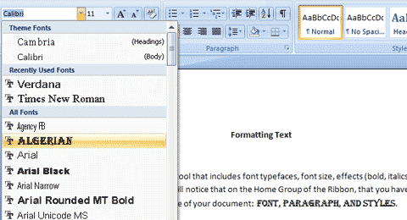

To change the font size:
- Click the arrow next to the font size and choose the appropriate size, or
- Click the increase or decrease font size buttons.
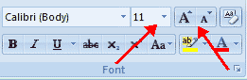
Font Styles and Effects
Font styles are predefined formatting options that are used to emphasize text. They include: Bold, Italic, and Underline. To add these to text:
- Select the text and click the Font Styles included on the Font Group of the Ribbon, or
- Select the text and right click to display the font tools
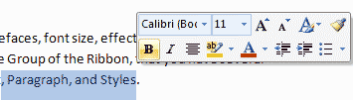
Change Text Color
To change the text color:
- Select the text and click the Colors button included on the Font Group of the Ribbon, or
- Highlight the text and right click and choose the colors tool.
- Select the color by clicking the down arrow next to the font color button.
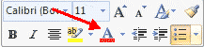

Highlight Text
Highlighting text allows you to use emphasize text as you would if you had a marker. To highlight text:
- Select the text
- Click the Highlight Button on the Font Group of the Ribbon, or
- Select the text and right click and select the highlight tool
- To change the color of the highlighter click on down arrow next to the highlight button.
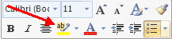

Copy Formatting
If you have already formatted text the way you want it and would like another portion of the document to have the same formatting, you can copy the formatting. To copy the formatting, do the following:
- Select the text with the formatting you want to copy.
- Copy the format of the text selected by clicking the Format Painter button on the Clipboard Group of the Home Tab
- Apply the copied format by selecting the text and clicking on it.
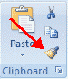

Clear Formatting
To clear text formatting:
- Select the text you wish to clear the formatting
- Click the Styles dialogue box on the Styles Group on the Home Tab
- Click Clear All
