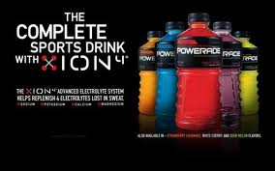
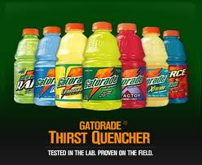
Creating a Sports Drink
Students will use the 4 P’s Marketing Concept through the creation of a Sports Drink.
A major manufacturer of beverages has just hired you. Your first assignment is to work with a team that has been given the responsibility of developing a brand new sports drink. You will develop the product idea, packaging, brand name, beverage name, and price.
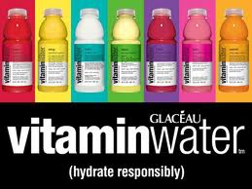
Most products are aimed at specific consumers called target markets. Target Markets are specific consumers that have wants and needs in common and therefore would be looking for the same specific product. Three to six year old children and their buyers (their parents) would want a different beverage than serious athletes or retired individuals sixty to eighty years old. The product needs to meet the needs and wants of the target consumers. You will be creating this sports drink for the following target market: teenagers, male and female.
In groups of two, or individually, you will use the 4 P’s to develop and market your sports drink:
1- Product Design: Determine the contents, portion size and flavor(s) of your drink.
2- Price your Product: Price for producer, for retailers, for consumers.
3- Promotion of your Product: Produce an attractive package and a form of advertising.
4- Place - Sell your product to the stockholders (class).
PROMOTION & SELLING
Promotion is letting people know about products and services in a positive way so they will want to buy. Promotion tells us what is available. Promotion PERSUADES us to buy one product instead of another. Promotion REMINDS us of a product that we already know about. Promotion INFORMS us of new ways to use a product or about guarantees or special ingredients. PACKAGING is part of promotion. It can persuade, remind and inform us. Packaging sells the product in addition to protecting it. Your package and its design will help set apart your product from all other sports drinks on the store shelf. The package design must attract the consumer’s eye and motivate him/her to purchase your beverage.
You were employed by a major beverage manufacturer to produce, price and package a new sports drink for teenagers. Now you must present your idea to the stockholders (your class) to see if they will support the production of this beverage. You will be PROMOTING YOUR PRODUCT - presenting it in a positive way so the stockholders will buy your idea. They must believe that your target market will buy your product instead of the competitors. Your team will do a 1 or 2 minute presentation that will include (if you’re in groups of two, each person must talk):
- Persuasive Introduction: Opening statement or skit that says your sports drink is a great product.
- Description: Description of your new beverage, including any special add-ons. Show your package or idea and point out the name of the company, sports drink and any special features including any promotional ideas that are included (Power words, celebrity, games, discounts, etc.) Why your product meets the needs & wants of your target market: List any special features, newer, price, nutrition, etc. that will appeal to your target market.
- Conclusion: A statement encouraging your stockholders (class) to develop this sports drink product and your belief that it will do well against the competition.

Project Grade:

 | Possible Points | Points Received
Work Ethic | 15
Colorful, Creative Sports Drink Bottle | 25
4 P’s used accurately as they pertain to the product | 30
Product Sales Pitch | 30
Total Points Earned | 100

